[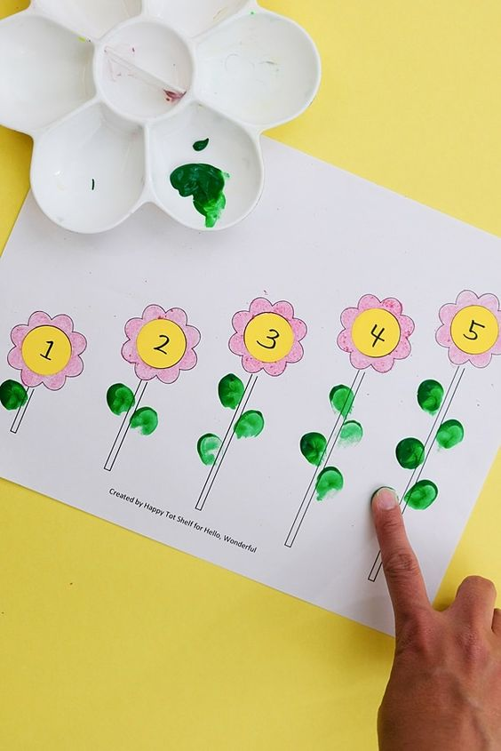](https://www.hellowonderful.co/post/flower-learning-printable/)**VÝTVARNÉ A PRACOVNÍ ČINNOSTI**

*[[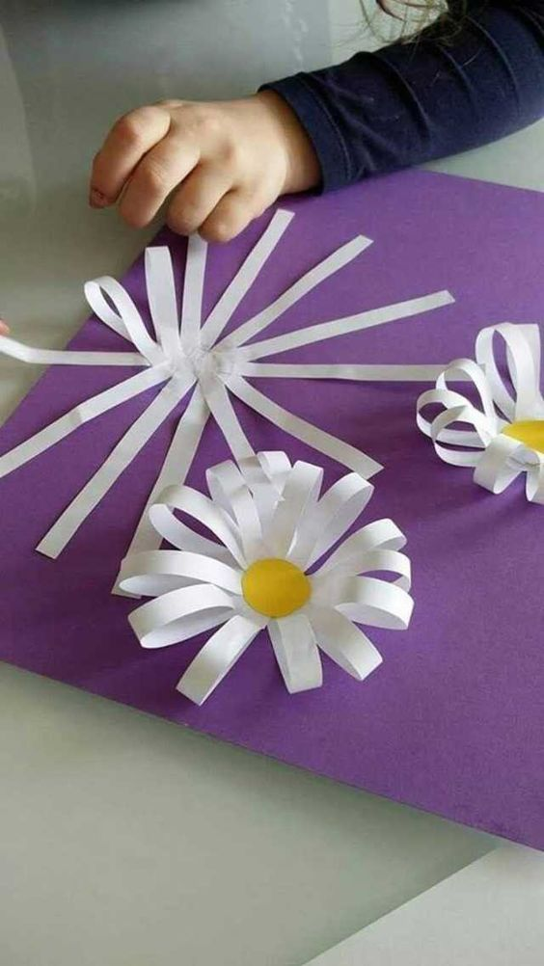](https://m.imgur.com/a/XgRU17l)](https://m.imgur.com/a/XgRU17l)*

[[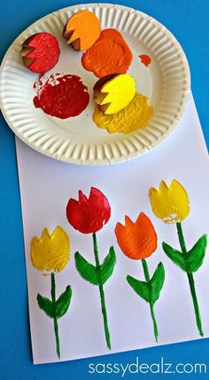](http://www.sassydealz.com/2014/04/tulip-potato-printing-craft-kids.html)](http://www.sassydealz.com/2014/04/tulip-potato-printing-craft-kids.html)

**LOGOPEDICKÁ PREVENCE**

[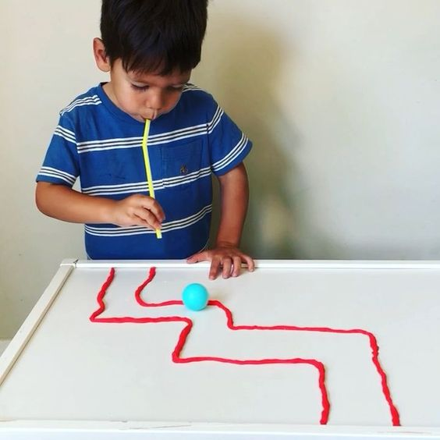](https://www.raisingdragons.com/ping-pong-playdough-straw-maze/)